CovidSIMVL Technical Report 004. On Calibrating R0, Hazard Radius and Mingle Factors

September 20, 2020

INTRODUCTION

The agent-based simulation tool CovidSIMVL is based on a predator-prey framework, in which the movement of agents (persons) and their subsequent positions may result in transmissions of a viral load between two agents that are in contact.

The PRIMARY rules for viral growth within an agent that is carrying a viral load, acquired by contact with an infective agent, Is based on temporal dynamics from a paper published by Xi, He et al. *Nature Medicine* **26,** 672-675(2020), expressed as shown below.

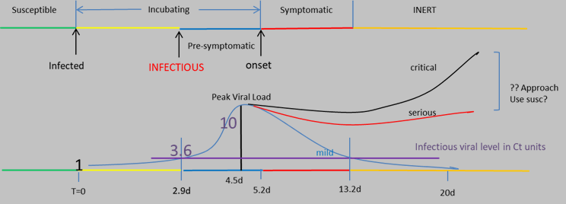

Each agent has one of the states: susceptible, incubating, aymptomatic infective, symptomatic infective, and inert (e.g., recovered and assumed no longer infective; deceased; quarantined). The viral loads determine the size of an agent (called the Hazard Radius).

The SECONDARY rules for the CovidSIMVL model concern the interaction between agents who are in their individual viral states. These rules operate on three factors:

1. The population density (number of agents in the fixed arena of 800 x 600 pixels
2. The Hazard Radius of the agents which stochastically change from a base value, according to their viral loads
3. The degree of activity, or Mingling Factor, of each agent, which may change from time and place according to their roles or purported degree of activity. The lower the activity of all agents, the less likely they are to contact, and the higher, the greater the likelihood. These movements can be considered as random walks, and the extent of the arena covered by the random walks of the agents together determine the likelihood of contact between agents.

RELATIONSHIP TO R0

In standard epidemiological studies of contagions, the notion of R0 is the number of successful transmission of an infectious agent to susceptibles in the duration of infectivity of that agent. While R0 is estimated in equation based modelling, CovidSIMVL can count these successful transmissions for each infective agent, and average them at any point.

If R0 characterizes specific local epidemics (BC, Alberta, Vancouver, Maine etc), and it has been found that R0 values < 1 represent self-extinguishing epidemics, while R0 values > 2 represent epidemics that are explosive in growth, the R0 values between 1 and 2 would appear to be epidemics that are continuing, but which can be held in check by various mitigations such as social distancing, infrequent mingling, the wearing of masks, reducing time indoors, etc.

CovidSIMVL Trials

Each set of parameters in CovidSIMVL represents a specific starting state. The stochastic nature of move generation, viral transference, initial spatial arrangement of the population, makes each such trial unique,within confines set by the range of values that a given parameter can assume. The allowable ranges of values for parameters for a given series of trials locates the a stochastically-varying set of results for those trials to be grouped together into a class.

In keeping with basic characteristics of repeated sampling in probability and statistics, we assume that the outcome of trials based on a certain set of parameters converge to a mean value which may differ from the outcome of other parameter settings.

We have run a number of trials with different parameter settings, to obtain two sets of outcomes:

1. The value of R0 at the time of the termination of a trial
2. The values of the Critical Exposure Times in the deciles 1 to 5 (explained below in the discussion of “goals”, in the sense of statistical benchmarks or cut-offs).

We have used as parameters:

1. The population size
2. The Hazard Radius of the agents (uniform to start with at 2, 3, 4 and 5).
3. The Mingle Factor (degree of activity) of the agents: individually they are preset to 3, and then these are modified by a universal Mingling Factor for the space, which modifies the activity of the individual as a product.

In other words, the final Mingle Factor of an agent is the individual MF X Universal MF

Iterations with Trials

Each trial entails a number of iterations, each of which culminates in a description of number of key quantities, namely, the numbers of susciptiles, incubating persons, asymptomatic infectives, symptomatic infectives, and inerts. Changes in those quantities over time reflect the dynamics of spread of the infectious agent.

The duration of the iterations can be set within a series of trials. For example, the duration could be set to an hour, which is useful when modeling dynamics that are associated with changes to agents within a 24 hour period, e.g., students spending a portion of the day in school, and a portion of the day at home.

A duration could be set for a day if the intention is to look at changes in rates over the course days, and there is no need or interest to factor in and portray changes at a more granular level

OUTCOME MEASURES OF R0

A given trial may be set up to iterate until values are produced for a series of outcomes or goal states:

1. The first 10% of agents newly infectd
2. The point at which 20% agents are infected
3. The point at which 30% agents are infected
4. The point at which 40% of agents are infected
5. The point at which 50% of agents are infected

Note that for certain configurations of parameters, a particular trial may end before goal a is reached. For example, the trial may end after only a few transmissions if there are no longer any infectious persons within the population specified for the trial

Consider, for example, a trail that was set up to terminate as Newly Infected = 50%. At that point, the number of generations required to reach each interim/final goal state is recorded, as well as R0 at that point. The trials records look like this:

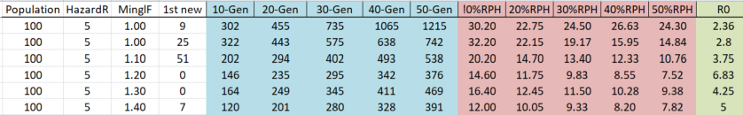

The result of these trials, as far as R0 is concerned, can be seen in the following graph:

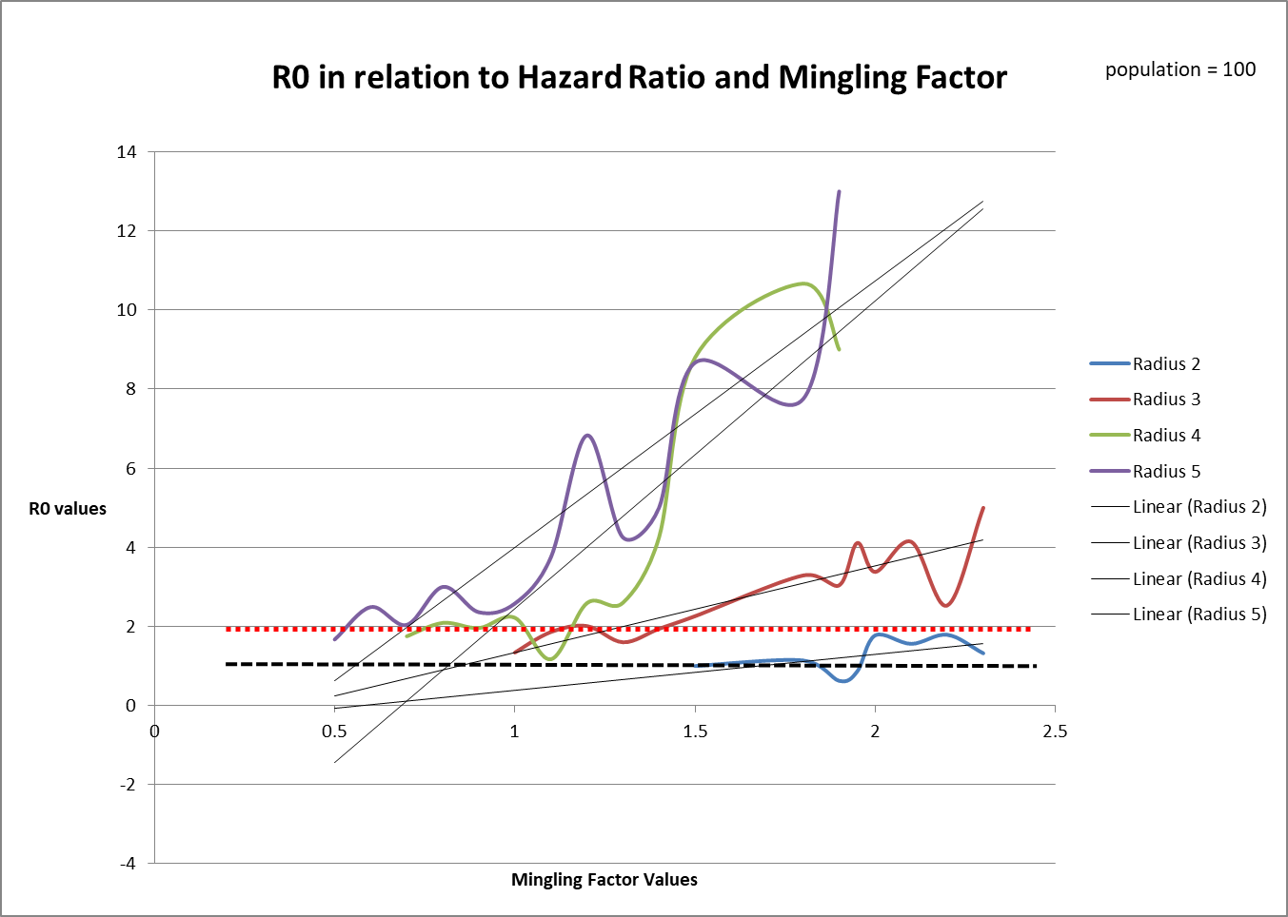

The important observations here are:

1. For different Hazard Radius values, the values of within 1 and 2 (black and red dotted lines) are different for the distinct Mingling Factors. For example, most values of R0 for Hazard Radius of 5 are greater than 2 when the Mingling Factors is greater than 0.5.
2. For Radius = 2, the values of R0 are consistently below 2, and for Mingling Factor < 1.8, the values of R0 are < 1. These represent Trials which terminate before the goal of 50% infected.
3. For each value of Hazard Radius, the starting point at which R0 is meaningful is different. This is because, below these limits, the Trials show that the simulations terminate very early or do not proceed at all (ie no contacts at all if the entities are very small and the movement is very small).

In the Discussion section, we will consider how these observations can inform the use of CovidSIMVL as a planning tool.

OUTCOME MEASURES OF RISK PER HOUR

Consider a trial in which 10 agents are infected in 25 generations. With each generation representing an HOUR of time, each infection happens on the average 10/25 or 1/(2.5).

This is the Risk per Hour, within the first decile (10% or 10 agents where population=100) of infection. For dramatic impact and simplicity, we will express the Risk per Hour as the denominator. In other words, if the Risk per Hour is 8.5, we mean a risk of infection of 1 in 8.5. Clearly, the smaller the Risk per Hour in denominator terms, the higher the risk of infection.

We calculate this metric at each of the points where 10% of the population are infected, 20%, 30%, 40% and 50%, in order to capture the number of generations the trial took to get those levels of infection.

These trials, relating the Risk per Hour to the deciles for families of Mingling Factors, for the set parameters Hazard Radius = 5 in a population of 100 in the fixed arena, result in the graph below.

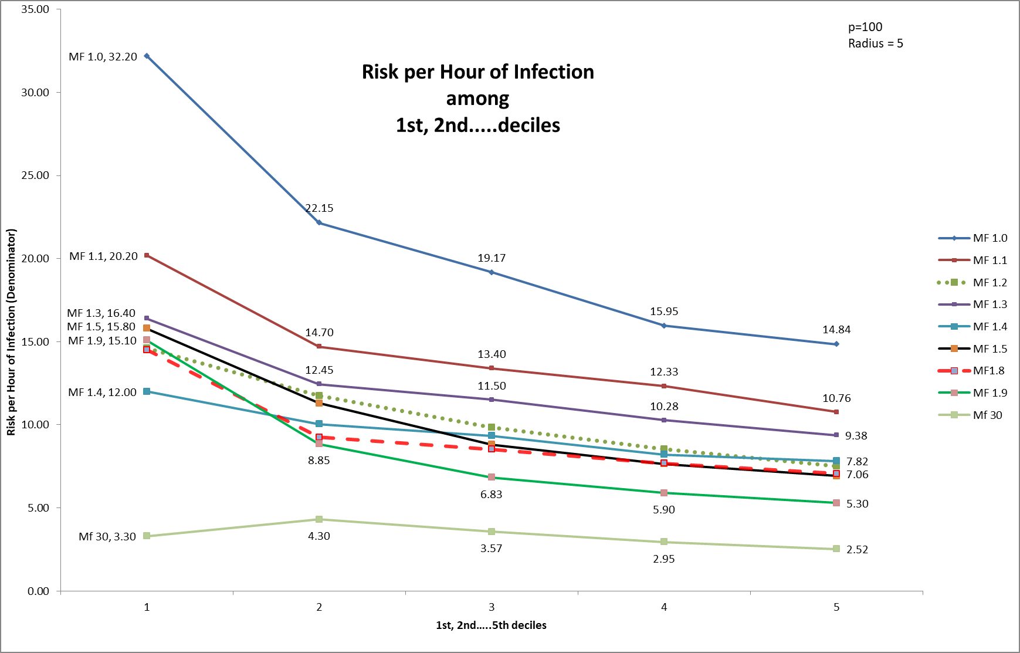

Consider the Mingle Factor MF=1.0 which is hardly moving at all. The Risk per Hour in the 10% decile is 32.30. Carrying on from this, the next waypoint is at the 20% mark, and this has Risk per Hour of 22.35.

For the Mingle Factor of 30 (very high activity), the Risk per Hour is successively 3.3, 4.30, 3.57, 2.95, and 2.52. Expressed as the risk of infection of 1 in 3.57, this is very high.

It might be useful to observe that these Trials are for continuous hours for 24hrs per day, and with CovidSIMVL, we can model specific hours in which different groups of people (agents) with characterizably distinct transmission risk profiles (e.g., younger children vs high school aged children vs staff in long-term care vs patients in long term care) are located in a particular universe. At other times during the day, they may or may not move to other universes (and carry the infection with them if they are incubating or infectious).

Take the example of a classroom, which has a student in it for say 6 hrs a day. If the Risk per Hour is 30, or 1 in 30 hours, this might be optimistically interpreted to be 5 days at 6 hours/day with the risk being 1/30 per hour for an infection to take place. In 30 hours, we will get ONE infection, from this population.

By contrast, if the Risk per Hour for that student is 6, or 1 in 6 hours, this might be interpreted to be 1 infection per 6 hours of classroom time (1 school day), with a risk per hour of 1/6.

High Mingle Factors produce higher Risk per Hour metrics, because the agents are more mobile and they are more likely to make contact in any particular generation within the model. The susceptibes that are contacted and transform into infections diminish the total number of susceptibles in the starting population and add to the number of infectives. This results in a greater effective density of infectives within the population, and greater risk for any of the uninfected (susceptible) persons.

Recall that Risk per Hour in this methodology is expressed as the number of hours required for one new transmission. As such, smaller numbers reflect higher risk. A declining Risk per Hour with increasing deciles can be interpreted to mean that the contagion is expanding in terms of rate, that it is easier to infect susceptibles as time goes on. In other words, the numbers of infective agents grows larger than the rate of their removal, considering the temporal dynamics of viral infection from incubating to infectious to inert.

Conversely, an increasing Risk per Hour with increasing deciles can be interpreted to mean that the contagion is decreasing in terms of rate, that it becomes more difficult to find susceptibles as time advances, that the rate of removal of infectives exceeds the rate of generation of new infectives.

Where the decline is steep in Risk per Hour, we would expect R0 to be large, and where the Risk per Hour increases with deciles, we would expect R0 to be certainly less than 2, if not less than 1.

The graph above shows a decline in general for the entire family of Mingle Factors, in part because these are in the Hazard Radius = 5 parameter space. We would expect HR=4 and HR=3 to have different shapes for their graphs, but as we saw in the R0 graph, the Mingle Factors might occupy different intervals for the Hazard Radius in question.

The graphs for Hazard Radius 4 and HR=3 is seen below.

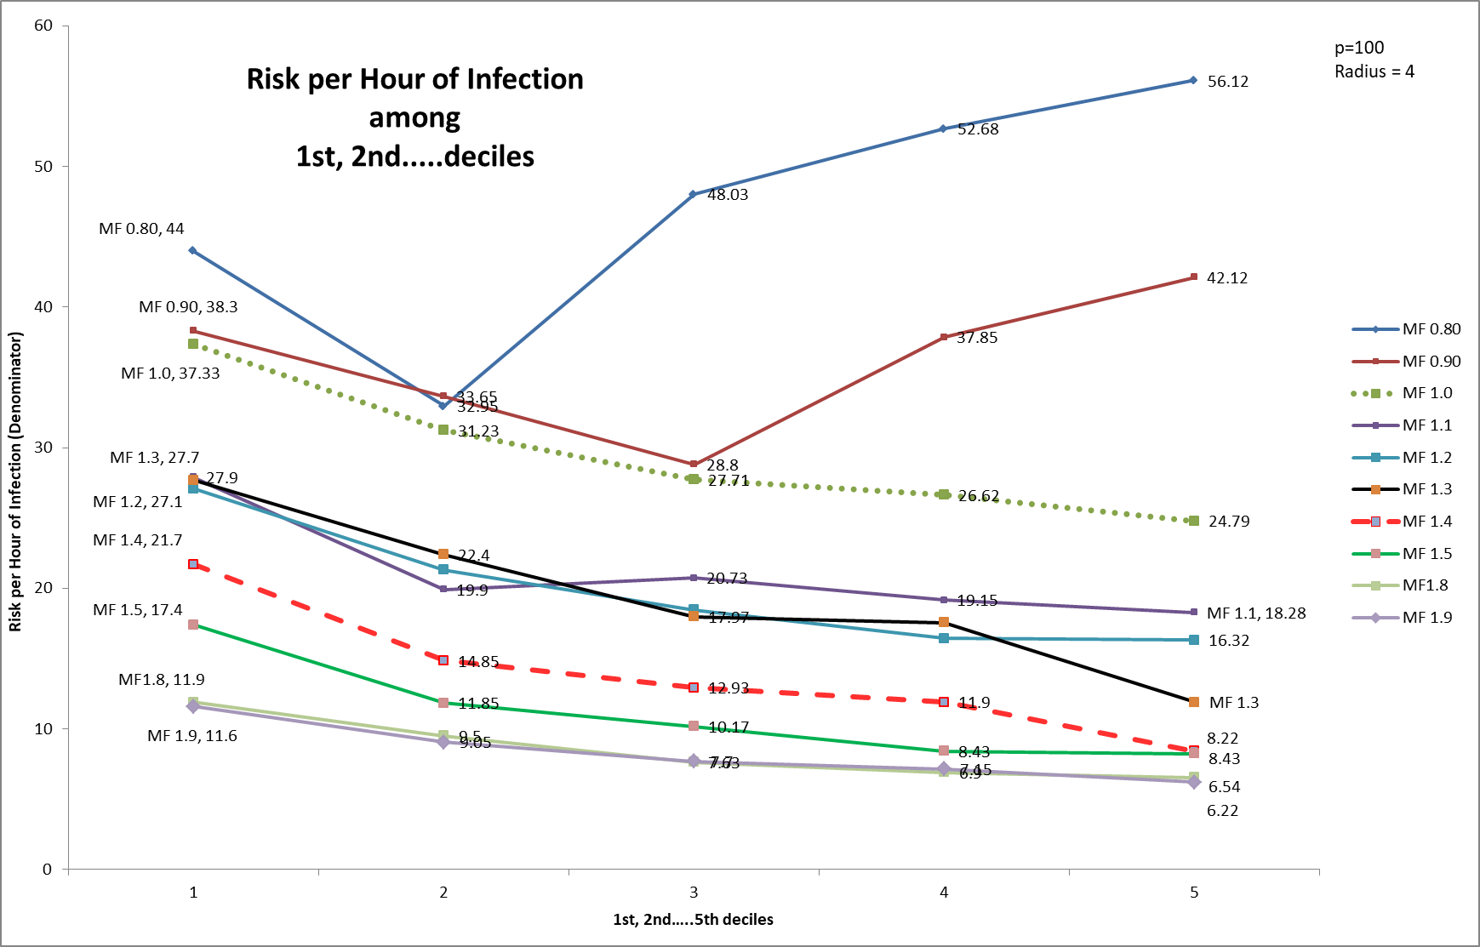

Note that the top two lines for MF=0.80 and MF=0.90 are upward sloping, showing that the Risk per Hour is a larger denominator, so the actual risk is 1/56 per hour for the 5th decile, MF=0.80.

DISCUSSION

Recalling that CovidSIMVL is a simulation engine that models a PRIMARY set of rules (within-agent viral growth dynamics), a SECONDARY set of rules (between agent interactions in a fixed space – the subject of the above), it also has a TERTIARY set of rules, which govern the movement of populations between common spaces (which we call Universes).

The simulation tool is an acknowledgment that although we can specify the rules for primary, secondary and tertiary behaviors, we cannot easily determine the end-points or even the progress of the dynamics of the systems as a whole.

Thus, CovidSIMVL is a tool in which various parameters can be run and their resulting epidemics can be observed, with appropriate metrics. Indeed, the ability to change parameters and observe subsequent outcomes is fairly easily done where data retro-fitting models do not engage in these problem areas.

However, we understand epidemics by the traditional mathematical equation-based data retrofit methods, and thus the setting of parameters for CovidSSIMVL needs connection to the understanding of epidemics as they are commonly understood.

This is the purpose of the Calibration studies above. For a given fixed universe, and an epidemic progressing at a specific rate estimate of some R0 value, one can set Hazard Radius and Mingle Factors to reflect that R0 value (as initial conditions). The progress and prediction is not what is at stake; rather, the consequence of policies like restricting the flow between Universes, or the reduction of the duration of the infective symptomatic period by increased testing, and the quantitative results of the change in total infections, or infections per hour, can be derived.